Trade of Metal Fabrication
Module 2: | Thermal Processes
Unit 4: | Butt/Flat and Horizontal Outside Corners
 | Phase 2

Table of Contents
List of Figures 5
List of Tables 6
Document Release History 7
Module 2 – Thermal Processes 8
Unit 4 – Butt/Flat and Horizontal Outside Corners 8
Learning Outcome: 8
Key Learning Points: 8
Training Resources: 9
Key Learning Points Code: 9
Defects due to Faulty Technique Summarised 10
Undercut 10
Slag Inclusions 10
Incomplete Penetration 11
Lack of Fusion 11
Weld Imperfections 12
Lack of Fusion 12
Overlap 12
Porosity 12
Unsatisfactory Surface 12
Undercut 12
Cracking 13
Excessive Concavity 13
Excess Convexity 13
Excessive Penetration 13
Inclusion 13
Incomplete Penetration 13
Hazards of Arc Burn and Arc Eye 14
Arc Eye: 14
Arc Burn: 14
Safety in Manual Metal Arc Welding 15
Equipment 15
Eye Protection 15
General Procedure 16
Arc Eye 16
Protective Clothing and Equipment 17
Preparation for Welding 18
Distortion and Cracking 19
Distortion and Stresses in Welding 19
Types of Distortion 21
The Problems of Cracking in Welds 22
Control of Distortion 23
Before Welding 23
Clamps and Wedges 26
Pre-Heat 26
Chills 26
Weaving 26
Excess Weld Metal 26
Welding Speed 26
Peening 26
During Welding 27
Weld Sequence 27
Heat Affected Zone (HAZ) 28
Weld Symbols 29
Self Assessment 33
Answers to Questions 1-10. Module 2.Unit 4 37
Index 45

List of Figures
Figure 2 - Defects Due to Faulty Technique 12
Figure 3 - Lack of Fusion 13
Figure 1 - General Procedure 17
Figure 4 - Preparation for Welding 19
Figure 5 - Angular Distortion in a Butt Weld/Fillet Weld and Longitudinal and Transverse Distortion 20
Figure 6 - Methods of Balancing Heat Input 21
Figure 7 - 'Back to Back' Welding to Reduce Distortion 22
Figure 8 - The use of Large Blocks to Hold Thin Sheet in Place for Welding, and to act as 'Chills' 23
Figure 9 - Before Welding 25
Figure 10 - Back-to-Back Assemblies 25
Figure 11 - Restraining Methods 26
Figure 12 - Longitudinal and Transverse Shrinkage 26
Figure 13 - Weld Sequence 28
Figure 14 - Heat Affected Zone 29
Figure 15 - Welding and Riveting 31
Figure 16 - Weld Symbols 2 32
Figure 17 - Diagrammatic Representation of Principle Welding Positions 33

List of Tables
Table 1 - Recommended Filters 16

Document Release History
Date | Version | Comments
20/10/06 | First draft
05/12/06 | Implemented edits from Kenny.
13/12/13 | SOLAS transfer

Module 2 – Thermal Processes

Unit 4 – Butt/Flat and Horizontal Outside Corners
Duration – 15 Hours

Learning Outcome:
By the end of this unit each apprentice will be able to:
- Prepare parent metal for welding
- Tack weld
- Successfully weld an open square butt joint on 6mm plate using M.M.A. process, in the flat position
- Adjust current settings to suit application

Key Learning Points:
Rk D | Interpretation of weld symbols on fabrication drawings.
Sk Rk Sc | Identification of weld defects and their causes. (See “Weld Defects“ section in Module 2 Unit 3).
Sk Rk M | Correct current ranges.
Rk | Identification of welding terminology.
Sk | Pick up/stop and restart.
Sc Rk | Advantages and disadvantages of A.C. and D.C. welding plants.
Sc Rk | Heat affected zone (HAZ).
Sk Rk | Arc length and electrode slope and tilt angles – rate of travel.
Sk Rk | Control of distortion.
Sk Rk | Joint preparation.
Sk | Uniformity of weld profile.
H Rk | Safety – clothing gauntlets, goggles, aprons, shields, anti-flash glasses.
H | Hazards of arc burn and arc eye – dangers of contact lenses.
P | Personal initiative – problem solving – safety awareness and attitude.

Training Resources:
- Manual metal arc welding plant – safety clothing and equipment
- 2.5 and 3.2 electrodes, welding booths and extractors
- Safety booklet, handouts, films
- 75 x 6 x 150 long
- M.S. flat bar

Key Learning Points Code:
M = Maths D= Drawing RK = Related Knowledge Sc = Science
P = Personal Skills Sk = Skill H = Hazards

Defects due to Faulty Technique Summarised

Undercut
This reduction in cross section weakens the joint and creates a slag trap.

Cause
High current.
Arc too long.
Angle of electrode too inclined to joint face.
Joint preparation does not allow correct electrode angle.
Electrode too large for joint.
Insufficient depositing time at edge of weave.

Remedy
Reduce amperage.
Keep shorter arc.
Electrode should not be inclined less than 45 deg. to vertical face.
Allow more room in joint for manipulation of electrode.
Use smaller electrode size.
Pause for a moment at edge of weave to allow build-up.
(Weaving is more likely to produce undercut than a straight run.)
Therefore where possible use straight runs.)

Slag Inclusions
These are non-metallic particles trapped in the weld metal and may seriously reduce the strength of the welded joint.

Cause
May be trapped in undercut from previous run.
Joint preparation too restricted.

Irregular deposits allowing slag to be trapped.
Lack of penetration with slag trapped beneath weld bead.

Rust or mill scale, preventing full fusion.
Wrong electrode for position in which welding is done.

Remedy
If bad undercut present, clean slag out and cover with run from smaller size electrode.
Allow for adequate penetration and room for c1eaning out slag.
If very bad, chip or grind out irregularities.
Use smaller electrode with sufficient amperage to give adequate penetration.
Use suitable tools to remove all slag from comers, etc.
Clean joint before welding.
Use electrodes designed for position in which welding is done, otherwise proper control of slag is difficult.

If slag is present in a weld, chip, grind or flame gouge until removed and re-weld.

Incomplete Penetration
A gap left by failure of the weld metal to fill the root.

Cause
Current too low.
Electrode too large for joint.
Insufficient gap.
Angle of electrode.
Incorrect sequence.

Remedy
Use smaller electrode.
Increase current.
Allow wider gap.
If too inclined, does not give penetration.
Keep nearer to right angle to weld axis.
Use correct build-up sequence.

Lack of Fusion
Portions of the weld run do not fuse to the surface of the metal or edge of the joint.

Cause
Small electrodes used on heavy cold plate.
Current too low.
Wrong electrode angle.

Speed of travel.
Scale or dirt on joint surface.
Remedy
Use larger electrodes (preheat may be desirable).
Increase current.
Adjust angle so that arc is directed more into parent metal.
If too high, does not allow time for proper fusion.

Note: In overcoming these faults, it is often an advantage if the job can be positioned to allow welding to be done in the downhand position.
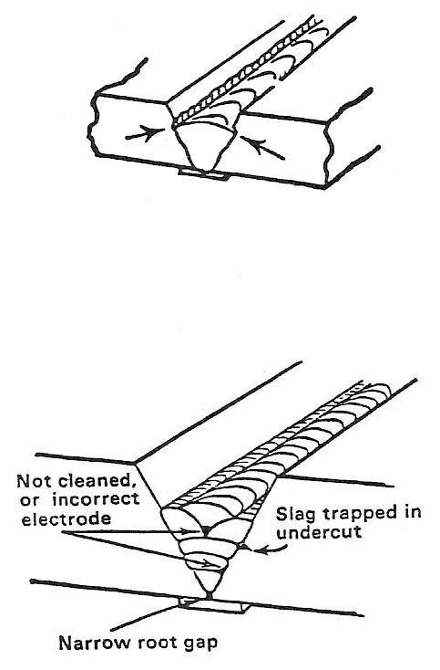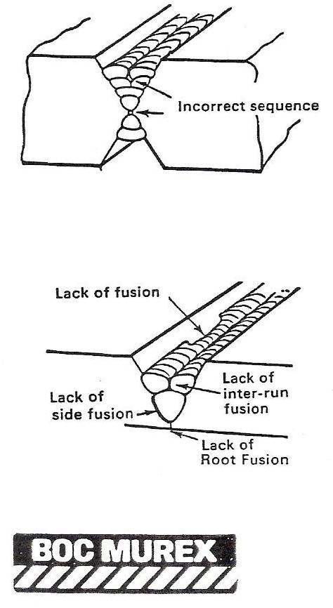
Figure 1 - Defects Due to Faulty Technique

Weld Imperfections

Lack of Fusion
Discontinuity of weld or failure to secure weld. Typical causes too low welding current or inadequate heat; too rapid travel with electrode or blowpipe; failure of molten deposited metal to 'wet' the parent metal; bad disposition of runs in a multi-run weld.
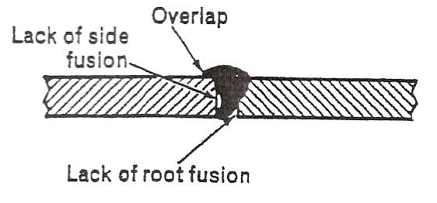
Figure 2 - Lack of Fusion

Overlap
Metal which has flowed on to the surface of the parent metal without fusing .to it.
Typical causes-contamination of parent metal; inadequate heat at toes of weld; incorrect welding technique.

Porosity
A group of pores in a weld caused by trapped gas.
Typical causes - contamination of parent metal or filler; high sulphur content of parent metal or filler; moisture trapped between faying surfaces; too rapid cooling of weld metal.

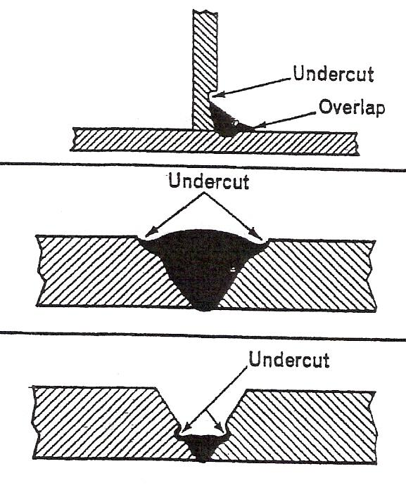
Unsatisfactory Surface
For example: poor surface finish, or irregular profile, or lack of smoothness in weld joint.
Typical causes - poor quality parent metal or filler; incorrect welding technique.

Undercut
A groove or hollow cut in the surface or fusion face of the parent metal at the toe of a run.
Typical causes - millscale on or near fusion face; too rapid travel of electrode or blowpipe; too high a concentration of heat; incorrect welding technique.

Cracking
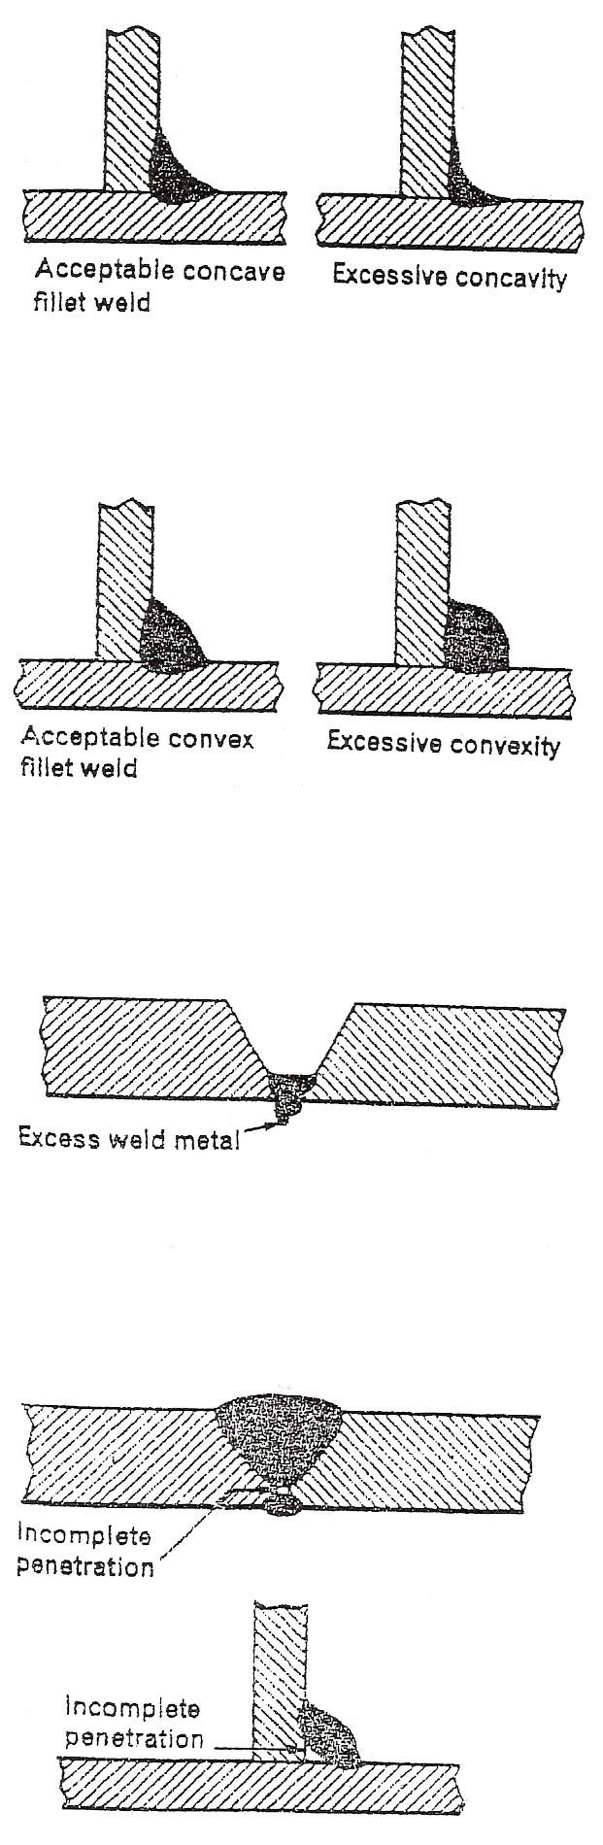
Cracks may appear anywhere in the weld or parent metals.
Typical causes - unsuitable parent metal or inappropriate welding technique.

Excessive Concavity
Usually refers to fillet welds with a too shallow throat.
Typical causes - too rapid travel with electrode or blowpipe; vertical welding using downwards method with inadequate addition of filler.

Excess Convexity
Excessive thickness at the throat of the weld.
Typical causes - unsuitable filler or electrode too low welding current or inadequate heat.

Excessive Penetration
Excess weld metal protruding through the root of a joint.
Typical causes - unsuitable edge preparation too high welding current or concentration of heat; too slow travel with electrode or blowpipe.

Inclusion
Slag or other foreign matter trapped in a weld.
Typical causes - unclean parent metal or filler: slag not cleaned from preceding runs; under-cutting cavities or grooves; tungsten from electrode in Tungsten-Arc Gas Shielded welding; accidental contact of nozzle with weld pool.

Incomplete Penetration
Failure of weld metal to extend into or fill the root of the joint.
Typical causes - unsuitable edge preparation; incorrect welding technique; inadequate back chipping or gouging of initial run before deposit.

Hazards of Arc Burn and Arc Eye
The arc given off from a welder, this can be an Arc, Mig or Tig Plant, is greater than the naked eye can deal with. The same applies to the hands/arms etc. Any part of the skin/eyes exposed to the bright arc light burns.

Arc Eye:
Dark filter glass (shade 10, 12, 13, etc.) in the welding shield protects the eyes from exposure. If for some reason your eyes get caught with arc flash on several occasions you may develop arc eye. It manifests itself several hours later and the person will experience severe irritation in the eyes.

Arc Burn:
Skin exposure, hands/arms/neck etc. is another form of severe sun burn. (A form of radiation e.g. sun rays).

The correct clothing, shields, gloves and aprons are listed in the next section.

Safety in Manual Metal Arc Welding

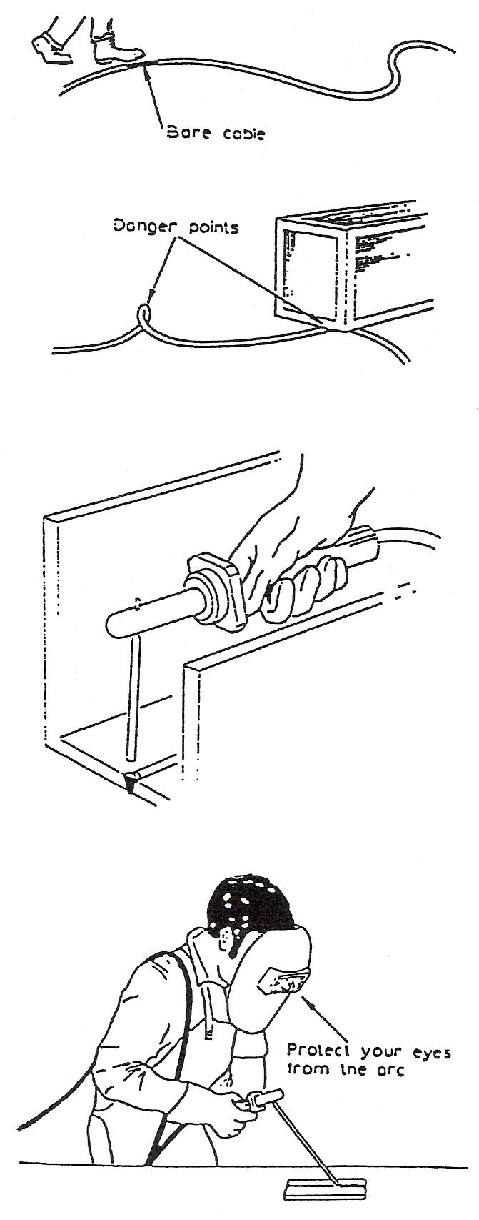
Equipment
The power supply for arc welding may be either a.c. or d.c. The voltages used are in order of up to 100 V and currents of up to 600 A. It is therefore essential that adequate precautions are observed to protect both operator and other personnel in the area of the risks associated with electricity. The following points should be observed when using arc welding equipment:
- Make sure that the welding circuit is correctly earthed.
- The welding cables should be adequately insulated. Never use damaged cables (top illustration).
- Ensure that the welding cables are free from kinks and that they do not become crushed or pinched under heavy loads (second illustration).
- Check that the power source is disconnected from the supply before attaching the cables to the terminals.
- Always use a fully insulated electrode holder when welding in confined spaces or where it is difficult to get access to weld without touching the surrounding metal (third illustration).

Eye Protection
It is essential to protect the eyes and face from the arc. The use of a face mask or head shield with the correct filter glass is essential.

Shade (B.S. 679) | Metal Arc Current
9 EW | Up to 100 A
11 EW | 100 – 300 A
13 EW | Over 300 A
Table 1 - Recommended Filters

General Procedure
However trivial, minor injuries should be dealt with in a first-aid room. This is particularly important for removal of foreign bodies from the eye, and for the treatment of burns caused by hot metal or slag.
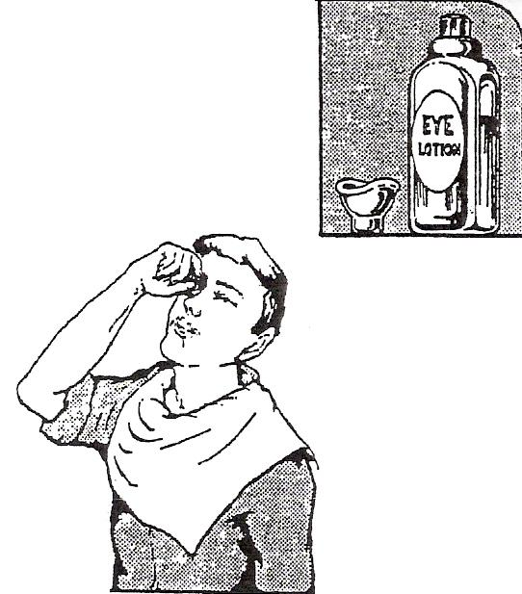
Figure 3 - General Procedure

Arc Eye
It is not unusual for irritation and watering of the eyes to start some hours after exposure to arc rays.
When symptoms occur:
- Use an eye bath to wash the eyes with an approved eye lotion.
- Repeat at about four-hourly intervals.
- In the meantime cold compresses, made by soaking cotton wool in cold water (which has been boiled previously), may be applied.
- If going into bright light, dark glasses should be worn.
- Report to the first-aid room as soon as possible.

If recovery from ‘Arc Eye’ is not complete in 36 to 48 hours, medical advice must be sought.

Protective Clothing and Equipment
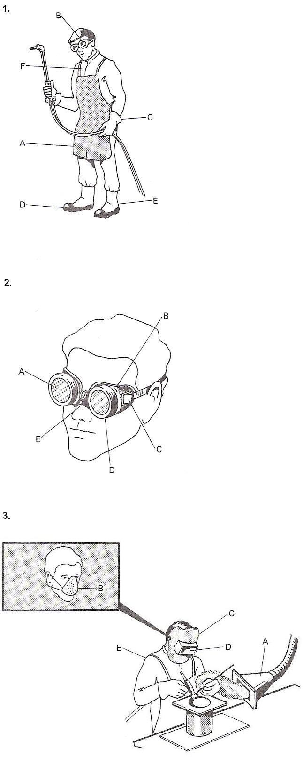
Figures 1, 2 and 3 illustrate examples of the use of protective clothing and equipment.
Figure 1 Name Main Use
A | Flame-resistant apron | Prevents burning of clothes.
B | Gas welding/cutting goggles | Protects eyes from sparks.
C | Gauntlets | Prevents skin burn.
D | Safety boots (steel toecap) | Prevents crushing of toes.
E | Spats | No molten metal down boots.
F | Boilersuit | Protects neck and chest.
Figure 2 Name Use
A (i) | Clear glass | Protects tinted lens.
A (ii) | Tinted lens | Limits glare.
B | Goggle body | Stops sparks.
C | Air vent | Prevents misting up.
D | Lens holder | To change broken lens.
E | Strap adjustor | Adjust for size.
Figure 3 Name Use
A | Extractor fan | Takes away fumes.
B | Filter mask | Dust and fumes.
C | Head shield | Prevents skin burn.
D (i) | Renewable clear glass | Takes spatter, etc.
D (ii) | Renewable tinted | Prevents arc eye.
E | Leather cape with sleeves | For overhead work.

The filter mask (Fig. 2) is no protection from dangerous gases such as phosgene (which is formed from degreasing agents such as trichloroethylene) or nitrous fumes (caused when large areas of plate are heated) or any other poisonous gases.

Preparation for Welding
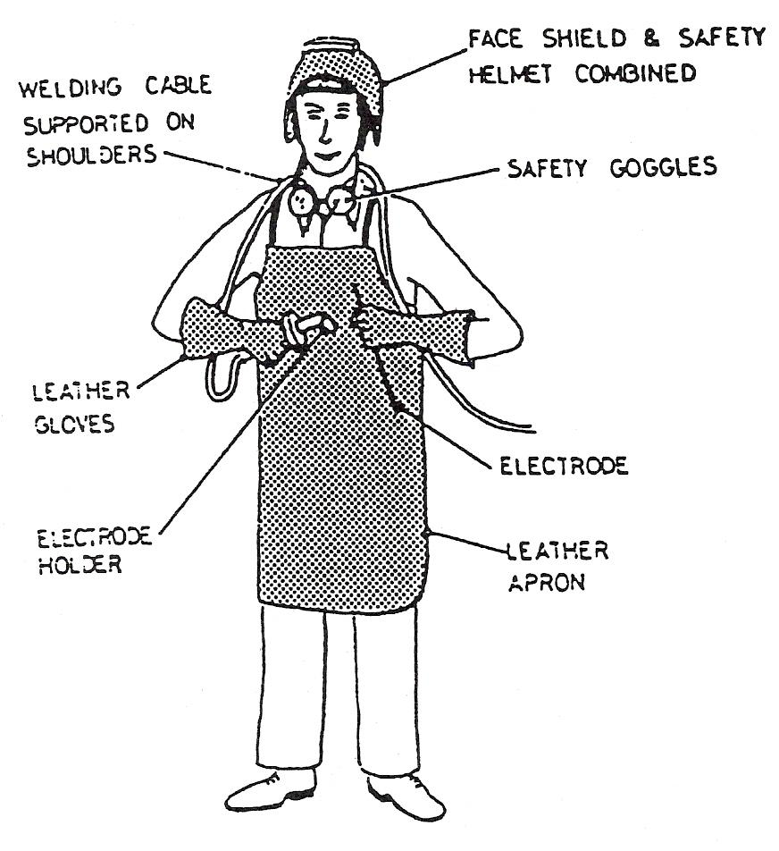
Figure 4 - Preparation for Welding

- Make sure that outer clothing is free from oil, grease or flammable material.
- Protect your arms from exposure to arc rays.
- Cuffs on overalls and turn-ups on Trousers are lodging places for sparks, try to cover them up.
- Ensure that the welding shield contains the glass and that it is not cracked or damaged.

Distortion and Cracking
Welding methods that involve the melting of metal at the site of the joint necessarily are prone to shrinkage as the heated metal cools. Shrinkage, in turn, can introduce residual stresses and both longitudinal and rotational distortion. Distortion can pose a major problem, since the final product is not the desired shape. To alleviate rotational distortion, the workpieces can be offset, so that the welding results in a correctly shaped piece. Other methods of limiting distortion, such as clamping the workpieces in place, cause the build-up of residual stress in the heat-affected zone of the base material. These stresses can reduce the strength of the base material, and can lead to catastrophic failure through cold cracking, as in the case of several of the Liberty Ships. Cold cracking is limited to steels, and is associated with the formation of martensite as the weld cools. The cracking occurs in the heat-affected zone of the base material. To reduce me amount of distortion and residual stresses, the amount of heat input should be limited, and the welding sequence used should not be from one end directly to the other, but rather in segments. The other type of cracking, hot cracking or solidification cracking, can occur in all metals, and happens in the fusion zone of a weld. To diminish the probability of this type of cracking, excess material restraint should be avoided and a proper filler material should be utilised.

Distortion and Stresses in Welding
When metal is subjected to a source of heat, it will expand. However, if the heat is applied to one area only, the expansion can be local and therefore uneven.
The metal surrounding the heated area can remain comparatively cool and tend to prevent expansion of the heated area. Therefore, if the yield point of the metal is reached, permanent deformation will occur. On cooling, the metal does not return to its original form but remains distorted. The same effect can happen in cooling; the surrounding cooler metal can offer resistance, and contractional stresses can also add to the distortion. The amount of distortion that takes place has a large influence on the amount of structural strain that will stay in the metal after it has cooled.
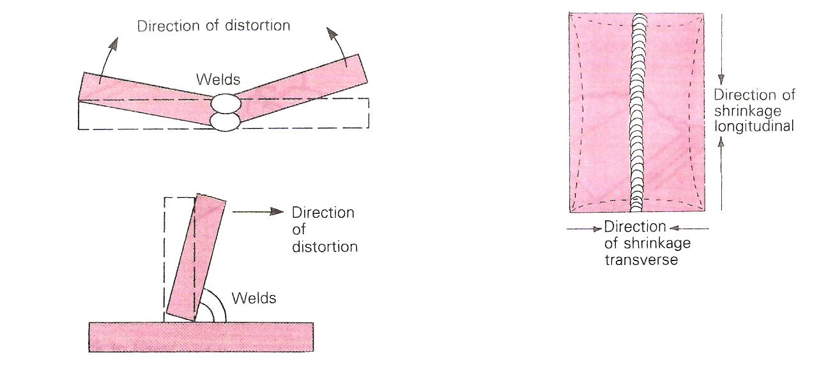
Figure 5 - Angular Distortion in a Butt Weld/Fillet Weld and Longitudinal and Transverse Distortion
As the amount of distortion increases, the amount of strain in the metal will be reduced, influenced by a reduction in plastic flow. However, if restraint is placed on the metal to prevent distortion, residual stresses will remain after the metal has cooled, and the final structure will be in a stressed condition. This situation can be remedied in most instances by a process known as stress-relieving, which involves controlled reheating of the component to a carefully predetermined temperature that is normally below the recrystallisation temperature. Stress can therefore be removed without too much disturbance of the metal’s grain structure.

In welding, the amount of weld metal deposited is relatively small compared with the parent metal. The greatest amount of heat is therefore concentrated in this area. Also, as the strength of the weld metal will be greatly reduced at high temperatures, and since it is such a small mass when compared with the structure as a whole, the weld will be forced to take most of the plastic flow as the structure cools. If this plastic flow is greater than the metal’s ultimate tensile strength, then a fracture can result.

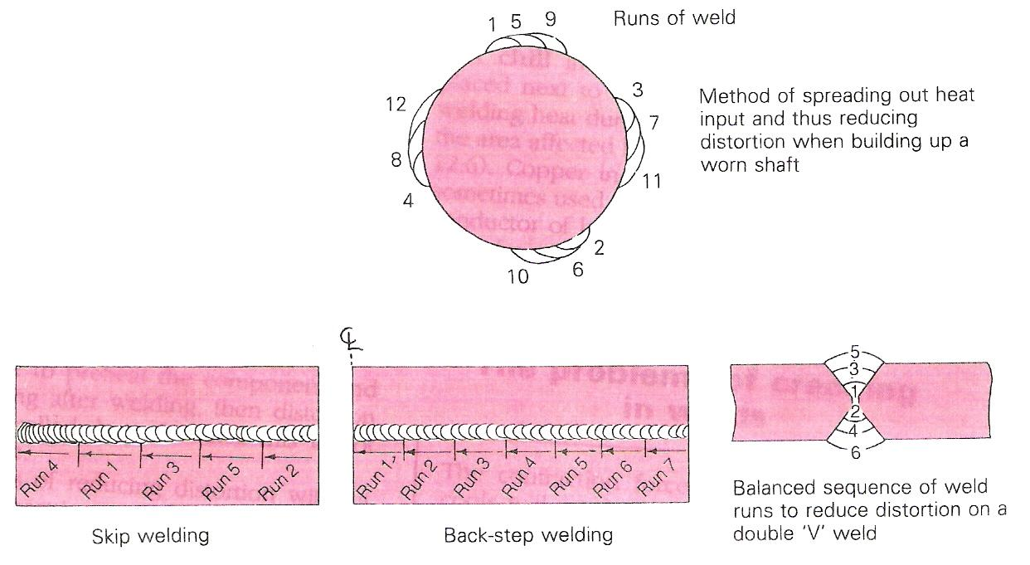
Figure 6 - Methods of Balancing Heat Input

Types of Distortion
There are three main types of distortion that can be set up in welded structures if care and preventive measures are not taken: angular distortion, longitudinal distortion and transverse distortion (Figure 5).
One method of overcoming angular distortion is to preset the plates to be welded. In other words, they are set in the opposite direction, so that when distortion takes place, the plates will pull into the required position. A test weld can be made and the amount of distortion measured with a protractor. The plates for the actual fabrication can then be preset to the required angle, thus compensating for angular distortion and minimising residual stresses.
Distortion can be minimised right from the design stage, by reducing the amount of welding to as low an amount as possible. This can involve using folds in the material or using welding processes with the lowest heat input available.
If it is possible to preheat the component and control the cooling after welding, then distortion can also be controlled, but of course this is not always practicable.
There are ways of reducing distortion without preheating or presetting, using weld sequences such as skip and backstepping, or using the shrinkage of one weld to counteract the shrinkage of another, as in the welding of a double 'V' joint or when building up a worn shaft (Figure 6).
Figure 7 shows how, for components of the same dimensions, back to back welding can reduce distortion. Clamps or tack welds are only removed when the components have fully cooled down.
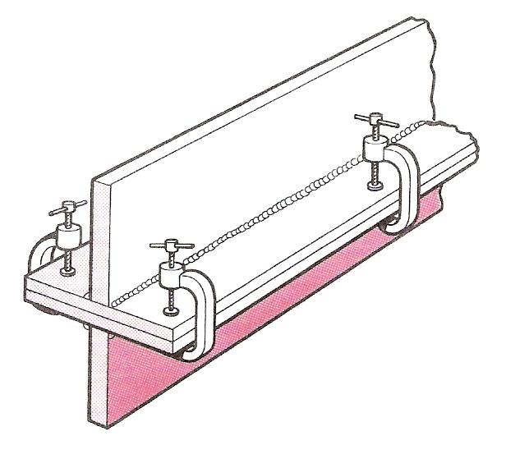
Figure 7 - 'Back to Back' Welding to Reduce Distortion

It is important to remember that stresses can be introduced into materials during manufacturing processes, such as forming and cold rolling. Then, when the metal is heated during welding operations, the stresses are relieved but distortion is introduced.
A chill in welding is a large block of metal placed next to the line of weld. It dissipates the welding heat during actual welding and minimises the area affected by the welding heat input (Figure 8). Copper in the form of a block or strip is sometimes used as a chill because it is a very good conductor of heat and will therefore conduct heat away from the weld area. Chills are therefore another method of distortion control.

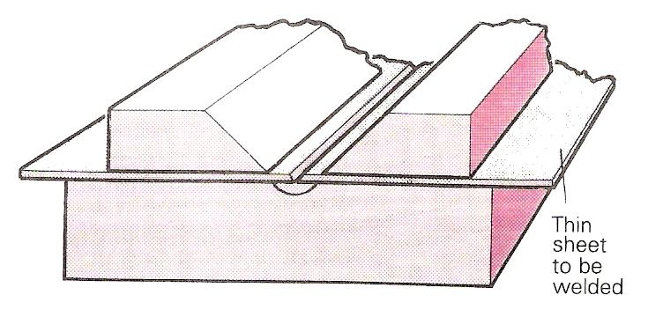
Figure 8 - The use of Large Blocks to Hold Thin Sheet in Place for Welding, and to act as 'Chills'

The Problems of Cracking in Welds

The contraction forces occurring as a weld cools will set up tensile stresses in the joint and may cause what is one of the most serious of weld defects: cracking.

Control of Distortion

Before Welding
- a) Use correct welding procedure sheets (BS 499; 5135, 5500) and ensure a correct edge preparation and fit-up. Use double-vee or double-U where flatness is important for thick plates. (Double-U has the least volume of weld metal.) A 2 mm root gap is reasonable to ensure penetration.
b) Ensure that plates are not misaligned and choose a welding process which produces the least distortion, for example, electroslag for thick slab, tags-mags or spot welding rather than oxy-acetylene for thin sheet.
- a) Make shrinkage forces (see Figure 9) work to achieve correct alignment by the use of pre-setting.
PRE-SETIING Locate parts in such a position that they pull into line due to the contracting weld metal. Examples are shown in Figure 9. The shrinkage direction is shown by the arrows. This method is employed on sub-assemblies as the parts have complete freedom to move. Restraint methods are usually used for final assembly.
To minimise stress, the direction of welding should be away from the point of restraint to the point of maximum freedom. A correct tacking formula should be used for the particular metal being welded if tacks are used.
b) PRE-CAMBERING The plates to be welded are kinked in a press, or rolled slightly, or cambered using clamps to counter the shrinkage. Figure 9 shows examples of distortion and countermeasures.
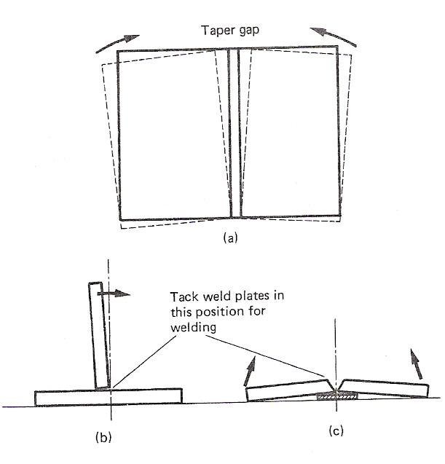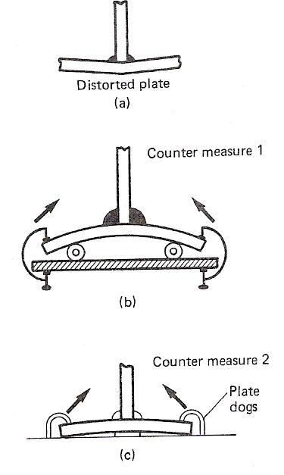
Figure 9 - Before Welding

- BACK-TO-BACK ASSEMBLIES (to avoid bowing) Identical or similar components are used to restrain and balance the weld shrinkage of each other, when fastened back to back. Typical examples are given in Figure 10 a, b and a balanced weld sequence is shown at c.

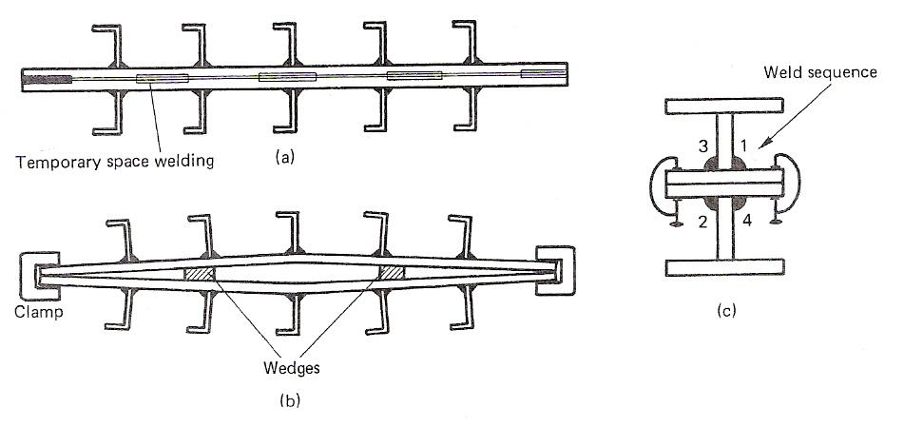
Figure 10 - Back-to-Back Assemblies

- RESTRAINING METHODS Jigs and fixtures may be used to restrain or control movements of the components during welding. If close control over accuracy is required, then restraint of the workpiece may be achieved by using wedges, strongbacks, chains, clamps and stays, which remain in position during cooling. As these methods prevent most of the movement, there is progressive build-up of stress in the fabrication. Where necessary, stress relief is carried out with the stays, etc. in position (Figure 11).
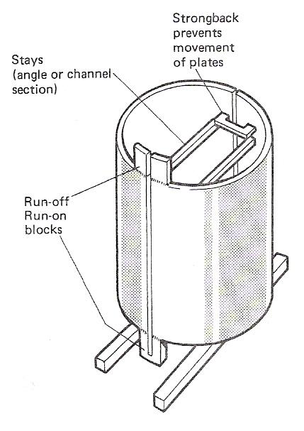
Figure 11 - Restraining Methods
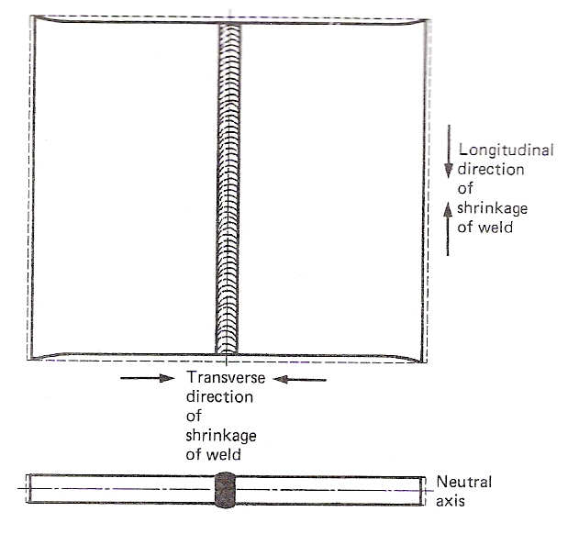
Figure 12 - Longitudinal and Transverse Shrinkage

Clamps and Wedges
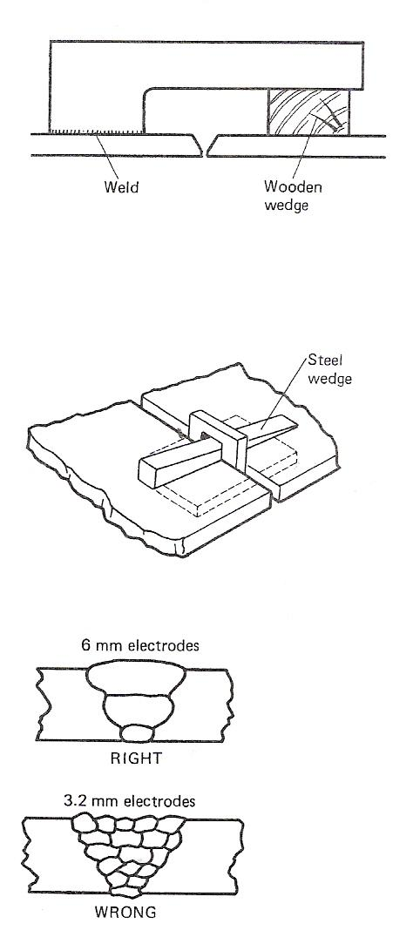
The first illustration shows a method of controlled shrinkage. Use may be made of spacer wedges (second illustration), clamps and cleats to hold plates in alignment. They are removed as the welding progresses or after completion.

Pre-Heat
Pre-heating and control of interpass temperature, especially on low alloy steels, controls the rate of shrinkage, and hence distortion.

Chills
Although used extensively when welding thin plate, chills are only occasionally used in thick plate welding. They are used to extract heat quite rapidly from a specific place on the weldment, to prevent "burn through" or to prevent heat spread at critical places. Chills may be in the form of copper, water-cooled backing pieces, soft aluminium blocks or machined cast iron supports.

Weaving
Excessive weaving and deposition of excess weld metal in any part of the fabrication at one time should be avoided. It is good practice to limit the weave to no more than 3 times the electrode diameter.

Excess Weld Metal
Avoid over-welding. This means that weld metal should be kept to a minimum consistent with requirements. It is a costly mistake to deposit excess-weld metal, as this increases distortion but not strength. Use the minimum number of runs unless otherwise stated. The third illustration gives an example.

Welding Speed
The optimum speed of travel should be used because too slow a speed tends to increase distortion.

Peening
Careful peening between runs promotes a stretching effect which counteracts the shrinkage. Used especially when welding cast iron.

During Welding

Weld Sequence
The order in which welds are to be carried out should be clearly marked on the fabrication before welding commences. A balanced welding sequence should be used so that successive weld runs pull against each other from each side of the neutral axis to retain alignment. String lines and plumb bob will show relative movement. Examples are shown in the top illustration in Figure 13 of two methods of sequence welding. The bottom illustration in Figure 13 shows how a balanced sequence may be used to avoid angular distortion.
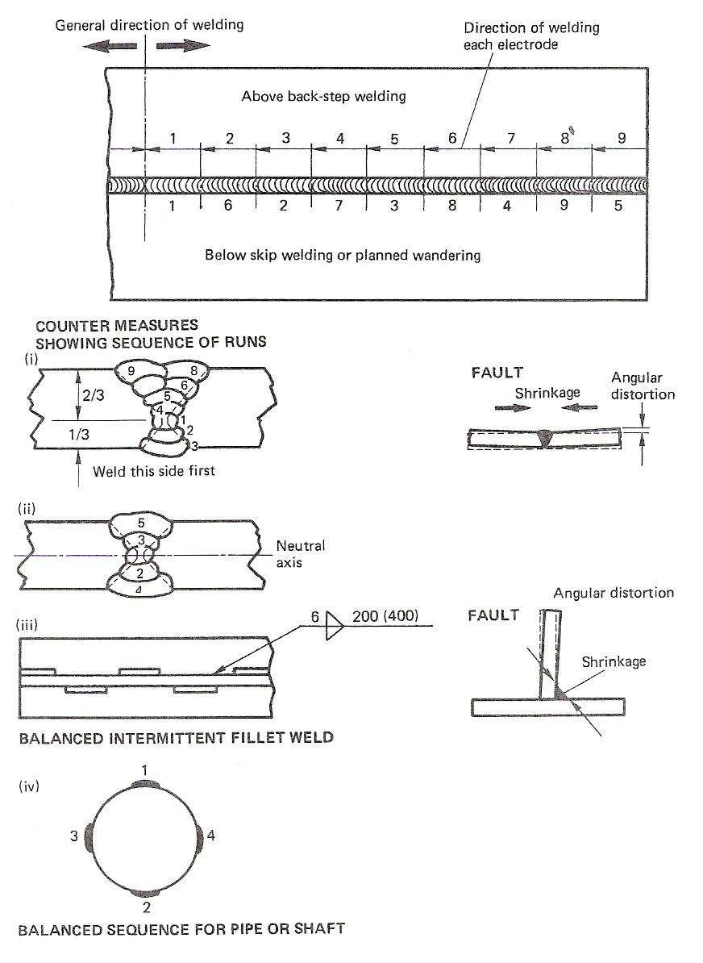
Figure 13 - Weld Sequence

Heat Affected Zone (HAZ)
This is the area on either side of the Fusion Zone on parent metals that has basically been heat affected due to the temperature of the weld. There is a similar zone after material has been cut using the Oxy/Acetylene Flame. In both cases the parent metal is not heated enough to change the crystal structure of the material.

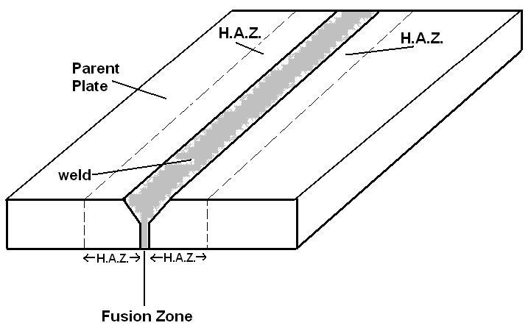
Figure 14 - Heat Affected Zone

Weld Symbols
Sketch | Description | Symbol
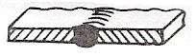 | Square butt weld: This symbol is used to indicate a stud weld when there is no end preparation and no fillet weld. | 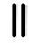
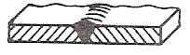 | Single-V butt weld. | 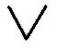
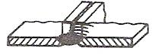 | Butt weld between flanged plates (the flanges being melted down completely).  Butt welds between flanged plates not completely penetrated are symbolised as square butt welds with the weld thicknesses shown.  s is the minimum distance from the external surface of the weld to the bottom of the penetration. | 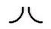
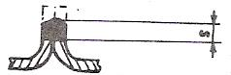 |  | 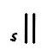
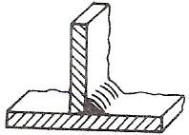 | Fillet weld. | 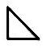
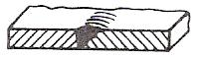 | Single-bevel butt weld. | 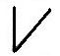
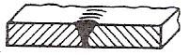 | Single-V butt weld with broad root face. | 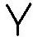
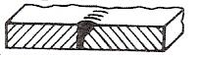 | Single-bevel butt weld with broad root face. | 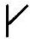
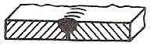 | Single-U butt weld. | 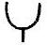
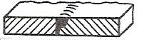 | Single-J butt weld. | 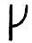
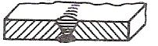 | Backing or sealing run.
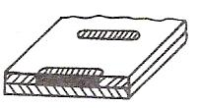 | Plug weld (circular or elongated hole, completely filled). | 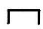
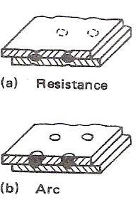 | Spot weld (resistance or arc welding) or projection weld. | 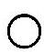
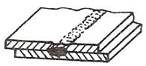 | Seam weld. | 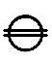
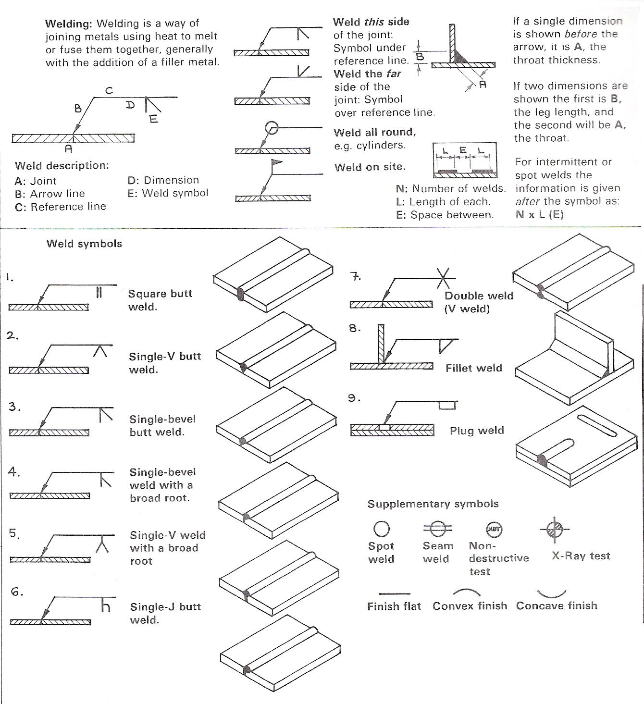
Figure 15 - Welding and Riveting
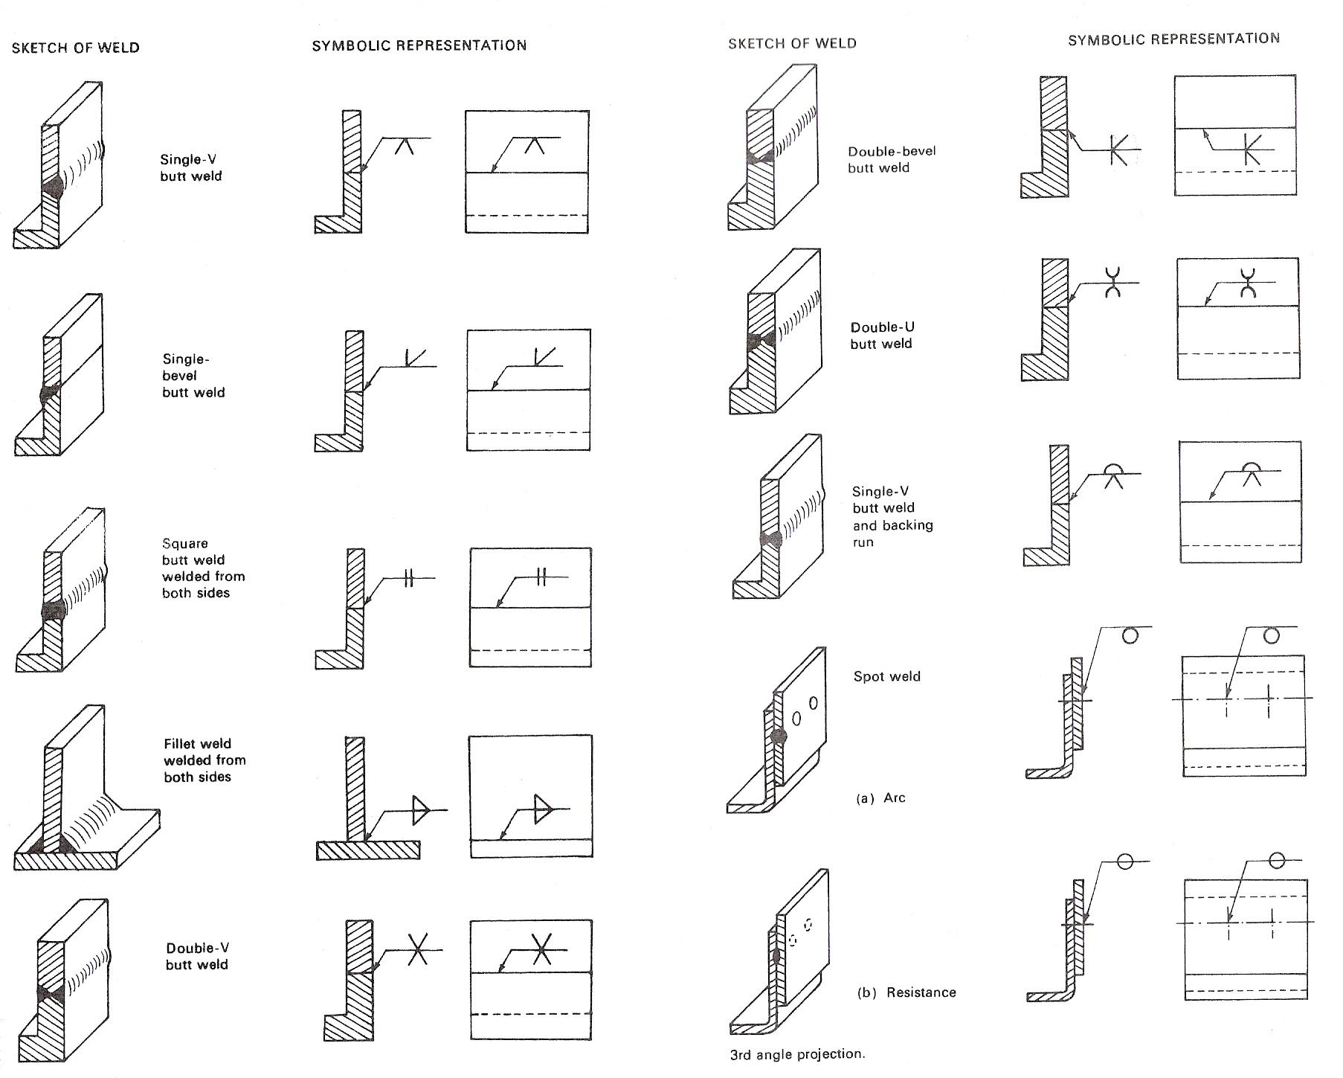
Figure 16 - Weld Symbols 2
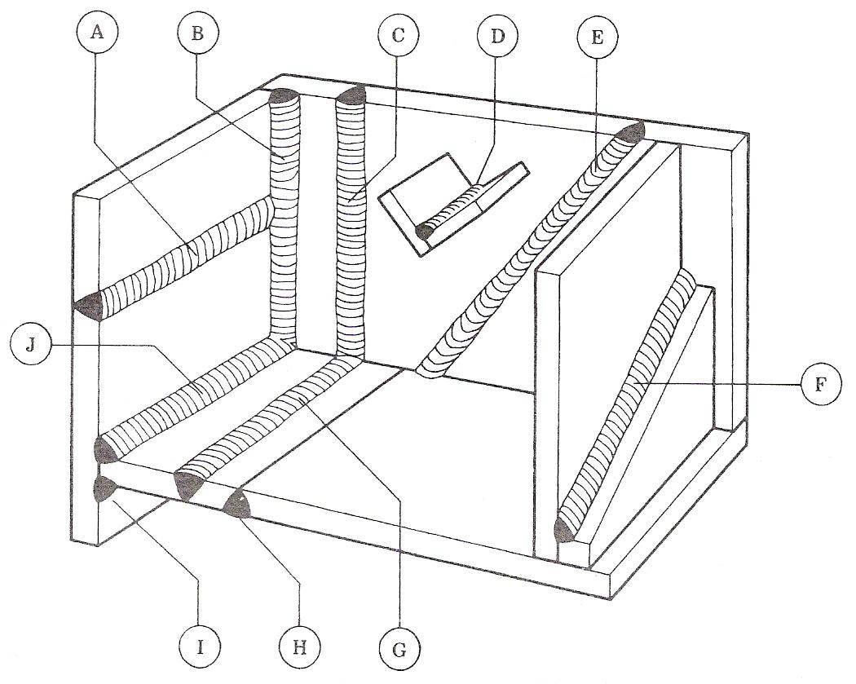
Figure 17 - Diagrammatic Representation of Principle Welding Positions

A – Horizontal-vertical
B – Vertical fillet
C – Vertical butt
D – Flat fillet
E – Inclined butt
F – Inclined fillet
G – Flat butt
H – Overhead butt
I – Overhead fillet
J – Horizontal-vertical fillet

BS 1719

Coding
-0-
-1-
-2-
-3-
-4-
Welding Positions
F, H, V, D, O
F, H, V, O
F, H
F
F, Hf (fillet welding only)

Self Assessment
Questions on Background Notes – Module 2.Unit 4

1. What is ‘Arc Eye’?

2. In relation to weld Defects / Imperfections, briefly explain:

a. Over Lap.
b. Undercut.
c. Slag.
d. Incomplete Penetration.

- List three safety points in Manual Metal Arc Welding.

4. List some of the causes of distortion and stresses in Welding

5. List two ways of controlling Distortion.

6. What does the term ‘Pre-Heating’ mean?

7. What does the term ‘Peening’ mean?

8. What does the Heat Affected Zone (HAZ) mean?

9. Sketch the Symbol for:

- Square Butt Weld
- Fillet Weld
- Spot Weld
- Seam Weld
- Single-Bevel Butt Weld.

10. With the aid of a diagram sketch and show the Root Face.

Answers to Questions 1-10. Module 2.Unit 4

1.

‘Arc Eye’
The Arc given off from a welder, is greater than the naked
eye can deal with. Dark filter glass in the welding shield
protects the eyes from exposure. If for some reason your
eyes get caught with Arc Flash you may develop Arc Eye.
It manifests itself several hours later and the person will
experience severe irritation in the eyes.

2.

WELD DEFECT | DESCRIPTION | CAUSE | REMEDY
a. Overlap | Metal which has flowed on to the surface of the parent metal without fusing to it. | Contamination of parent metal.  Inadequate heat at toes of  weld.  Incorrect welding technique.
b. Undercut | Reduction in cross section weakens the joint and creates a slag trap. | High current.  Arc to long.  Angle of electrode too inclined to joint face.  Joint preparation does not allow correct electrode angle.  Electrode too large for joint.  Insufficient depositing time at edge of weave. | Reduce amperage.  Keep shorter arc.  Electrode should not be inclined less than 45° to vertical face.  Allow more room in joint for manipulation of electrode.  Use smaller electrode size.  Pause at edge of weave to allow build up.

2. Continued:

WELD DEFECT | DESCRIPTION | CAUSE | REMEDY
c. Slag | These are non-metallic particles trapped in the weld metal and may seriously reduce the strength of the welded joint. | May be trapped in undercut from previous run.  Joint preparation too restricted.  Irregular deposits allowing slag to be trapped.  Lack of penetration with slag trapped beneath weld bead.  Rust or mill scale, preventing full fusion.  Wrong electrode for position in which welding is done. | If bad undercut present, clean out slag, cover with run from smaller electrode.  Allow adequate penetration and room for cleaning out slag.  If very bad, chip or grind out.  Use smaller electrode with sufficient amperage to give adequate penetration.  Use suitable tools to remove slag from corners etc.  Clean joint before welding.  Use electrodes designed for the position in which welding is done.
d. Incomplete  penetration | A gap left by failure of the weld metal to fill the root. | Current too low.  Electrode too large for joint.  Insufficient gap.  Angle of electrode.  Incorrect sequence. | Use smaller electrode.  Increase current.  Allow wider gap.  If too inclined, does not give penetration.  Keep nearer to right angle to weld axis.  Use correct build up sequence.

3.

Safety:

Welding without the proper precautions can be a dangerous and
unhealthy practice. With new technology and proper protection
the risks are greatly reduced.

The risk of burns is significant, to prevent them, welders wear
personal protective equipment in the form of heavy leather gloves
and protective long sleeve jackets to avoid exposure to extreme heat
and flames.

Goggles and helmets with dark face plates are worn to protect from
Arc eye.

Welders are often exposed to dangerous gases. Flux-cored arc
welding and shield metal arc welding produce smoke containing
particles of various types of oxides which can in some cases lead to
medical conditions like Metal Fume Fever.

Furthermore because many welding processes pose an explosion
and fire risk, some common precautions include limiting the
amount of oxygen in the air and keeping combustible material
away from the workplace.

4.

Distortion and Stresses:
Welding methods that involve the melting of metal at the site
of the joint necessary are prone to shrinkage as the heated metal
cools. Shrinkage, in turn can introduce residual stresses and both
longitudinal and rotational distortion.
Distortion can pose a major problem, since the final product is
not the desired shape. To alleviate rotational distortion, the work-
pieces can be offset, so that the welding results in a correctly
shaped piece.
When metal is subjected to a source of heat, it will expand.
However, if the heat is applied to one area only, the expansion
can be local and therefore uneven.
On cooling, the metal does not return to its original form but
remains distorted. The same affect can happen in cooling; the
surrounding cooler metal can offer resistance, and contractional
stresses can also add to the distortion. The amount of distortion
that takes place has a large influence on the amount of structural
strain that will stay in the metal after it has cooled.
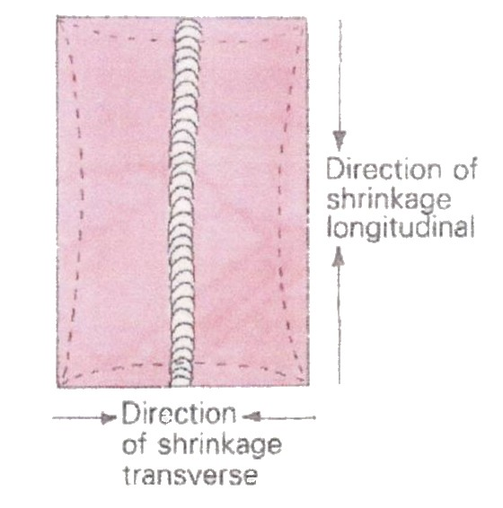
Figure 8. Figure 9.
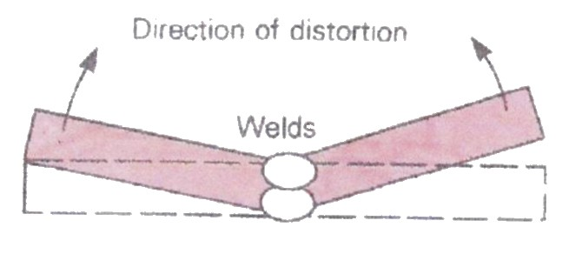

Figure 10.
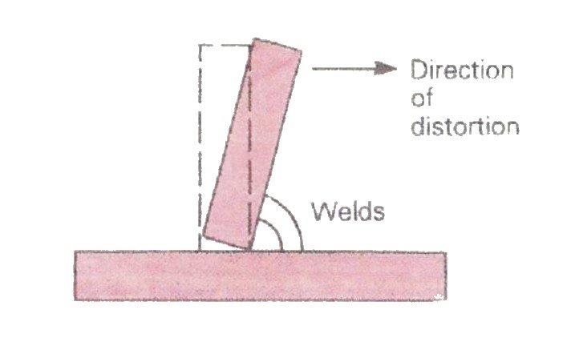

5.

Controlling Distortion:

Figure 11. Figure 12.

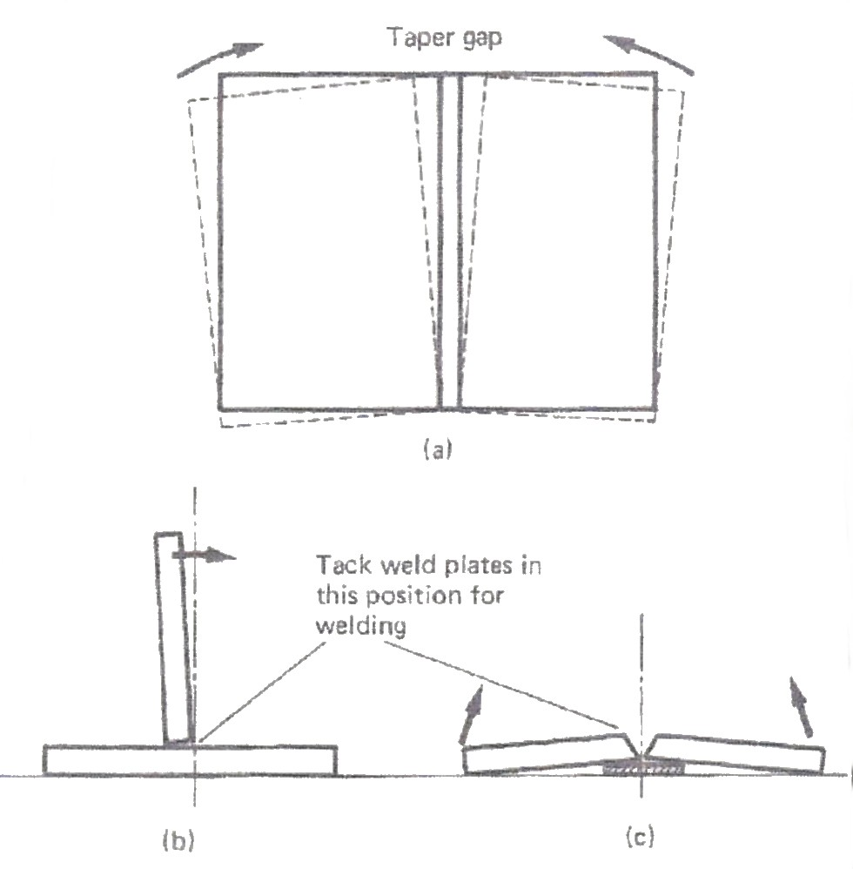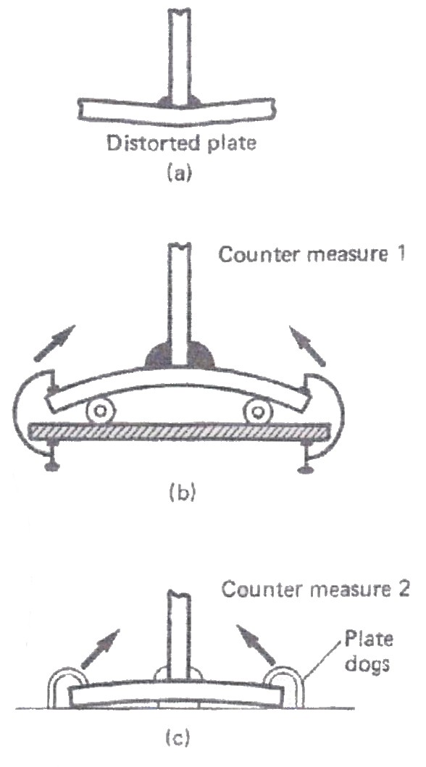

6.

Pre-Heating:
The temperature of the parent metal just before welding is
started. With some metals the parent metal is heated before
welding to avoid problems such as cracking or lack of fusion.

7.

Peening:
Careful peening between runs promotes a stretching effect
which counteracts the shrinkage. Used especially when welding
cast iron.

8.

Heat affected Zone: (HAZ)

This is the area on either side of the Fusion Zone on parent
metals that has basically been heat affected due to the temperature
of the weld. There is a similar zone after material has been cut
using the Oxy/Acetylene flame. In both cases the parent metal is
not heated enough to change the crystal structure of the material.
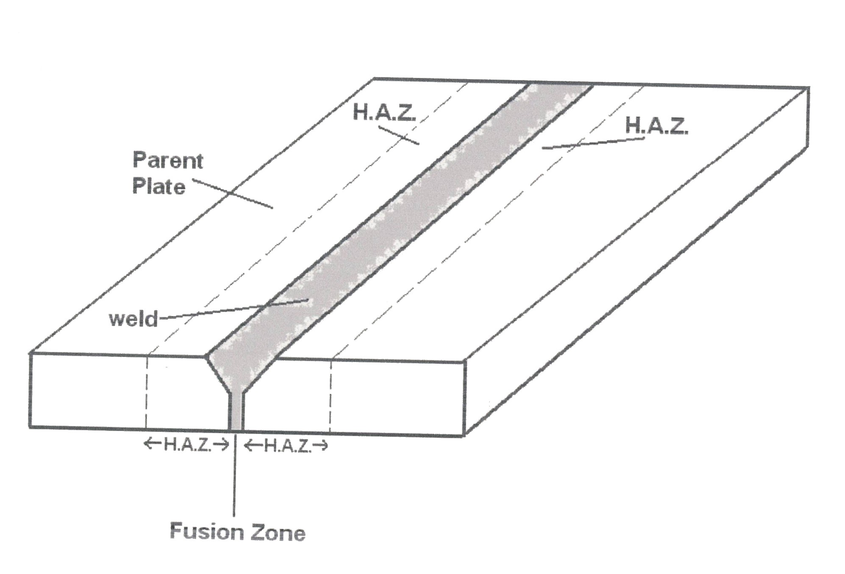

Figure 13.

9.

a. Square Butt Weld. This symbol is used to indicate a  stud weld when there is no end  preparation and no fillet weld. | 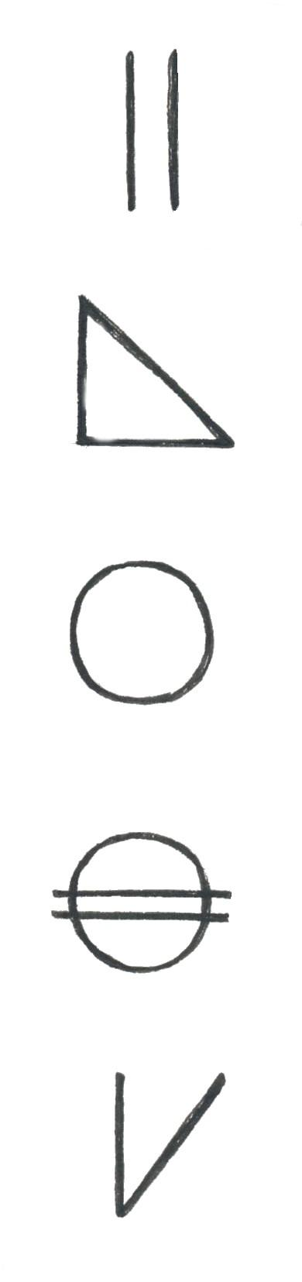
b. Fillet Weld.
c. Spot Weld. (resistance or arc welding) or
projection weld.
d. Seam Weld.
e. Single-bevel butt weld.

Figure 14.

10.

Root Face:

The surface formed by the ‘squaring - off’ of the root edge
of the fusion face to avoid a sharp edge at the root of the
preparation.

Figure 15.
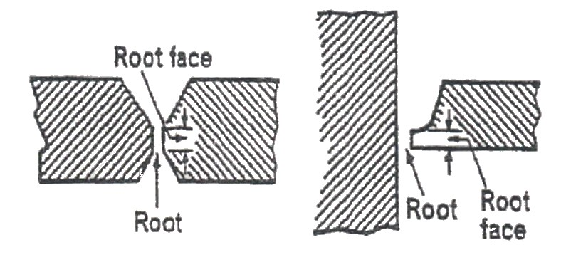

Index

C
Control of Distortion, 23
Control of Distortion (Welding)
Before Welding, 23
Chills, 26
Clamps and Wedges, 26
During Welding, 27
Excess Weld-Metal, 26
Peening, 26
Pre-Heat, 26
Weaving, 26
Welding Speed, 26
D
Defects due to Faulty Technique Summarised, 10
Incomplete Penetration, 11
Lack of Fusion, 11
Slag Inclusions, 10
Undercut, 10
Distortion and Cracking, 19
Distortion and Stresses in Welding, 19
The Problems of Cracking in Welds, 22
Types of Distortion, 21
During Welding
Weld Sequence, 27
G
General Procedure, 16
Arc Eye, 16
H
Hazards of Arc Burn and Arc Eye, 14
Arc Burn, 14
Arc Eye, 14
Heat Affected Zone (HAZ), 28
S
Safety in Manual Metal Arc Welding, 15
Equipment, 15
Eye Protection, 15
Preparation for Welding, 18
Protective Clothing and Equipment, 17
W
Weld Imperfections, 12
Cracking, 13
Excess Convexity, 13
Excessive Concavity, 13
Excessive Penetration, 13
Inclusion, 13
Incomplete Penetration, 13
Lack of Fusion, 12
Overlap, 12
Porosity, 12
Undercut, 12
Unsatisfactory Surface, 12
Weld Symbols, 29

